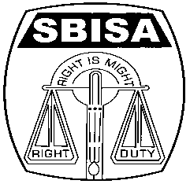 | Website: www.sbisabc.co.in |  | Telephone No : 2248-6024
 | Telegram : “MILITANT” |  | Tele Fax : 2248-7019 (UNION)
 | Mail ID : sbisa.bc@gmail.com |  | Tele Fax : 2243-6729 (LHO)
STATE BANK OF INDIA STAFF ASSOCIATION
(BENGAL CIRCLE)
(REGISTERED UNDER ACT XVI OF 1926)
(Affiliated with All India State Bank of India Staff Federation)
 | All letters to be addressed  to the General Secretary | “AJIT SEN BHAWAN”  13, Crooked Lane (1st Floor)  Post Box No. 2817  Kolkata – 700 069
CIRCULAR NO. BEN/KOL/51 TO ALL UNITS / MEMBERS DATE: 14.05.2019
FAREWELL TO COM. PASANG TAMANG
REGIONAL SECRETARY, REGION-IV, SILIGURI MODULE

Com. Pasang was appointed in the Bank as Clerk-cum-Cashier-cum Typist at our Gangtok branch on 26th August 1977. Subsequently he was transferred to Chungthang branch and Lead Bank and then to Regional office as Senior Assistant in 2001. Thereafter on Career Progression he was transferred to Gangtok branch as Special Assistant in the year 2005, then again on Career Progression as Senior Special Assistant to Deorali Bazar in the year 2014 and lastly in the year 2015 he was transferred back to Gangtok branch. His deep sense of organizational zeal and passion prompted him to become the Unit Secretary of Chungthang branch within a short period of his appointment in the Bank. His attachment and concern for the membership at large drew attention of the then leaders and he was inducted in the Circle committee as Regional Secretary, Region-IV in the year 2009 which he continued till the date of his retirement.

Com. Pasang had always advocated for the causes of members without any discrimination which made him very popular among them. He maintained strong organizational values and bonding among the members despite geographically far flung location of branches in the region and took active role in trade union activity in furthering the interest of the Organization in the Siliguri Module. He always supported the Module leadership with all kinds of data and other necessary materials. He played a major and active role in organizing the NCBE Conference of the Sikkim state in December 2018 which was a stupendous success.

Com. Pasang is a very soft person with a tender and feeling heart and possessing meek and genial nature. For his gentle manners together with concerned and focussed approach he can easily win the hearts of members.

Com. Pasang is going to lay down his office on 31st May 2019 from the Bank and also from the Association. We wish Com. Pasang a very happy, healthy and prosperous retired life. A grand farewell ceremony has been organized on 25th May 2019 at Cholkasum, Namnang Road, near Big Bazar, Gangtok at 11.30 AM where we request all our members to muster strong to bid adieu to Com. Pasang Tamang to make his farewell ceremony a grand success.

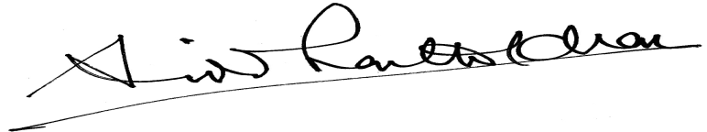

GENERAL SECRETARY

