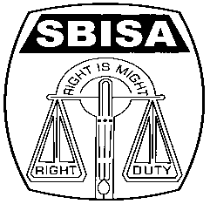 | Website: www.sbisabengalcircle.co.in |  | Telephone No : 2248-6024 (Union)
 | Telegram : “MILITANT” |  | Tele Fax : 2248-7019 (UNION)
 |  |  | Tele Fax : 2243-6729 (LHO)
STATE BANK OF INDIA STAFF ASSOCIATION
(BENGAL CIRCLE)
(REGISTERED UNDER ACT XVI OF 1926)
(Affiliated with All India State Bank of India Staff Federation)
 | All letters to be addressed  to the General Secretary | “AJIT SEN BHAWAN”  13, Crooked Lane (1st Floor)  Post Box No. 2817  Kolkata – 700 069
CIRCULAR NO. BEN/KOL/46 TO ALL UNITS / MEMBERS DATE: 18.03.2019

FAREWELL TO COM. KAJAL KUMAR DEY
ZONAL SECRETARY, BIDHANNAGAR MODULE

Com. Kajal Kumar Dey joined the Bank's service on 9th April 1980 at Birati branch. From the very beginning of his career he had a great inclination towards Trade Union activities which drew attention of the then leaders of the Association. He was quickly inducted as Delegate from the branch Unit in the year 1982 and thereafter he was elected as the Unit Secretary of the branch Unit in the year 1990. He continued to work for the welfare of the members during his stay in the branch. After his transfer to HB Town branch in 1993 he was elected as Unit Secretary cum Delegate in 1995. His dedication and commitment for the members and involvement in Trade Union activities did not stop here as he was inducted in the Circle Committee as Zonal Secretary in the year 2009. Later in the year 2010, he was elected as Regional Secretary of NCBE as well. He deftly performed in both the positions. Later in the year 2014 he took transferto Garulia branch and he continued in the post of Zonal Secretary till his retirement.

Com. Dey was always found concerned for members' cause and their rights and played an important role for furthering the organizing causes. He was a man of strict principle and values which was exhibited from his passion and commitment for the Trade union. Com. Dey could easily mix with people and always he was rooted to the ground and served the interest of the members with great zeal and enthusiasm.

Com. Dey is going to lay down his services from the Bank as well as from the Association on 31.03.2019. We wish a very healthy and happy retired life. To bid him a befitting adieu, a farewell function has been organized on 29th March'19 at Loksanskriti Bhawan, Sodepur at 5.30 pm where all our members are invited to make the farewell function of Com. Dey a memorable one.

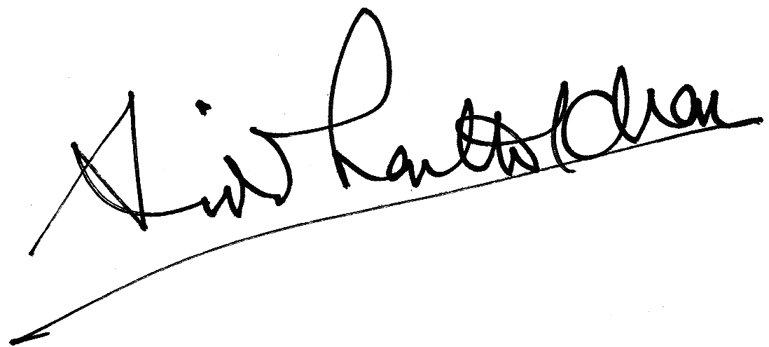

GENERAL SECRETARY

