 | Website:www.sbisabengalcircle.co.in | Telephone No. 2248-6024(Union)  Tele Fax : 2248-7019(union)  Tele Fax : 2243-6729 (LHO)
 | Mobile No. 9836652055(G.S.)
NATIONAL CONFEDERATION OF BANK EMPLOYEES
(WEST BENGAL STATE FEDERATION)
(Registered under the Trade Union Act 1926: Registration No. B-2334)
All letters to be addressed to the General Secretary | “AJIT SEN BHAWAN”  13, Crooked Lane (1st Floor)  Kolkata – 700 069
CIRCULAR NO. NCBE(WB)/58 TO ALL AFFILIATES/MEMBERS DATE: 09.08.2018

Dear Comrades,

DISCUSSIONS WITH IBA ON MEDICAL INSURANCE SCHEME
We reproduce hereunder the text of Circular No.22 dated the 8th August 2018 issued by Com. Sanjeev K. Bandlish, General Secretary, National Confederation of Bank Employees incorporated therein the UFBU Circular No.UFBU/2018/14 dated the 8th August, 2018 for information of all affiliates and members.

With revolutionary greetings,

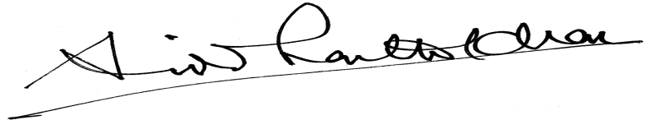
(SIDDHARTHA KHAN)
GENERAL SECRETARY
------------------------------------------------------------------------------------------------”As already informed to units, bipartite meeting was held today between IBA and UFBU regarding renewal of our Medical Insurance Policy for serving employees/ officers as well as for the retirees for the ensuing period 2018-19. IBA team was represented by Shri Rajkumar, Dy. Chief Executive, Shri S K Kakkar, Sr. Advisor (HR&IR), and Shri K S Chauhan, Sr. Vice President (HR). All our constituent unions were present in the meeting.

IBA informed us that United India Insurance Co. has given their proposal for hike in the premium on the Policies both for the serving employees/officers as well as for the retirees as under:

Serving employees/officers : Increase in premium by 29% over existing rate

Retirees (without Domiciliary) : Increase in premium by 110% over existing rate

Retirees (with Domiciliary) : Increase in premium by 144% over existing rate

We strongly objected to such steep hike in the rate of premium and informed the IBA that especially the hike in premium for the retirees is too exorbitant and not appearing to be relatable to actual claim ratio. We urged upon the IBA to take up with UIIC to drastically reduce the premium.

IBA informed us that they are already seized of the issue and the matter is being taken up with UIIC. We pointed out that the following points be kept in mind while finalizing the issue:

- There should be no attempt to discontinue the policy. Policy should be continued and renewed.
- The premium rates should be drastically revised downwards.
- Pending discussion with UIIC, the Policy for both serving employees and retirees should be extended upto 31-12-2018 with pro rata premium.
- Cost of upfront payment of annual premium should be factored in while finalizing the premium rate.

Contd….2

Page No. 2

- Change in age profile of serving employees and retirees should be taken into account while working out the revised premium rates.
- IBA should take up with the Government for exemption of GST on premium amount.
- Renewed Policy should include a penalty clause for delayed sanction of bills/ reimbursement.
- If broker will not be involved in the scheme, suitable mechanism should be put in place to deal with cases of repudiation of claims, etc.
- Uniform guidelines should be given by IBA for sanction of amount under Buffer allocation.
- Premium should be worked out on a composite basis by clubbing both serving employees and retirees.
- Premium for retirees should also be paid by the managements.

IBA took note of the above points raised by us and assured to keep these views in mind while further dealing with the same.

Next round of Talks on 18-8-2018: Next round of Bipartite Talks (Sub-Committee) will be held on 18th August, 2018. Discussions will be held in the forenoon with the Officers Associations and in the afternoon with Workman Unions.”

--------------------------------------------------------------------------------------------------

