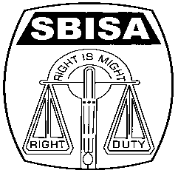 | Website: www.sbisabengalcircle.co.in |  | Telephone No : 2248-6024 (Union)
 | Telegram : “MILITANT” |  | Tele Fax : 2248-7019 (UNION)
 |  |  | Tele Fax : 2243-6729 (LHO)
STATE BANK OF INDIA STAFF ASSOCIATION
(BENGAL CIRCLE)
(REGISTERED UNDER ACT XVI OF 1926)
(Affiliated with All India State Bank of India Staff Federation)
 | All letters to be addressed  to the General Secretary | “AJIT SEN BHAWAN”  13, Crooked Lane (1st Floor)  Post Box No. 2817  Kolkata – 700 069
CIRCULAR NO. BEN/KOL/35 TO ALL UNITS / MEMBERS DATE: 27.08.2018

3rd CIRCLE COMMITTEE MEETING

The 3rd Circle Committee Meeting was held on19th August 2018 at the Jadavpur University campus, Teqip building seminar hall hosted by the Jadavpur University unit. The meeting was presided by the Circle President, Com. Animesh Chatterjee. At the outset, he welcomed all the Circle committee members in the meeting and narrated in short the functioning of Module functionaries in different Modules and then invited Com. General Secretary to speak on the agenda of Organizational matter.

Com. General Secretary mentioned about the Kerala flood situation and urged all to stand beside them at the time of need and even invited from members to suggest the amount of donation to be given for the flood victim. He stressed upon to make constant communication with members, visit branches and to flag the unresolved issues / problems in the Modular Structured meetings. He discussed at length on the following issues.

- Invitation of option for transfer of guards to their place of choice
- Legitimate mode of payment to members as per provision of Award working in marketing outfit as discussed in last CCC meeting.
- Left over overtime payment on account Demonetization to be paid by Bank as per decision of CCC Meeting.
- Celebration of centenary year of SBISA to make it a grand success.
- Stopping of transfers of staff above the age of 55/57 years.
- Rising frauds in different branches.
- Outsourcing of Cash Department jobs under Cash Efficiency Project and our stand to resist by launching agitation against such move as Bank has not entered into bilateral Agreement with Staff Federation.
- Dismantling of Central Accounts Office to the Corporate Centre Mumbai – Our stand to intensify the agitational programme jointly with the SBIOA.
- Towards resolution of issues of maintenance staff who were retrenched by the Bank.
- Resolving issues of Tamluk Railway Station branch and reversion of punishment meted out to eleven members at our intervention.
- Incident of Chakdah Town branch and resolution of the issue and our stand to give justice to all in a fair and just manner.

On the Organizational matter, the following speakers participated and expressed their views and in reply Com. General Secretary clarified their queries. It was unanimously passed by the House to donate a sum of Rs. 3 Lacs in support of the flood victims in Kerala state.
- Com. Sanjay Mukherjee
- Com. Pallab Sanyal
- Com. Passang Tamang
- Com. Debasish Banerjee
- Com. Unus Ali
- Com. Tarun Ghosh
- Com. Sudip Dutta
- Com. Dhiman Chatterjee
- Com. Animesh Naha Roy

Contd….2

Page No. 2

- Com Debabrata Das
- Com. Kaushik Roy
- Com. Kanishka Mukherjee
- Com. Gautam Hati.
- Com. Biswajit Pramanik
- Com. Arun Prakash Rai
- Com. Saswata Sikdar
- Com. Anupam Tarafdar
- Com. Debasish Basu Roy

Newly inducted Circle Committee member Com. Debabrata Das from Raiganj was felicitated by Com. General Secretary and Com. President.

Then Com. President asked Com. General Secretary to submit on the next agenda of Co-option in the posts lying vacant in the Circle committee. On proposition of names the following Office- bearers were co-opted and the house approved it unanimously.

BURDWAN MODULE

- Asish Banerjee (SME Burdwan) as Regional Secretary, Region-1 vice Com. Tara Shankar Rakshit ( since retired)
- Com. Somesh Das (RBO-5 ) as Zonal Secretary vice Com. Asish Banerjee

SILIGURI MODULE

- Com. Tapan Goswami (Malda Branch) as Zonal Secretary vice Com. Niruzaman Siddique ( promoted out of cadre)

MID-CORPORATE MODULE

- Com. Prasenjit Mitra (Commercial Branch) as Assistant General Secretary vice Com. Samar Mishra

S-24 PARGANAS MODULE

- Com. Samar Mishra (Sitalatala Branch) as Regional Secretary (R-1) vice Com. Chanchal Roy, Zonal Office, South 24-Parganas.

Com. Chanchal Roy proposed to be co-opted as Assistant General Secretary (HQr), NCBE (WB State Unit) vice Com. Ashok Banerjee (Since resigned). In the Working Committee Meeting of NCBE (WB) held on 26.08.2018 at the Union Office, Com. Chanchal Roy has been co-opted as AGS (HQ) of NCBE with thunderous applause.

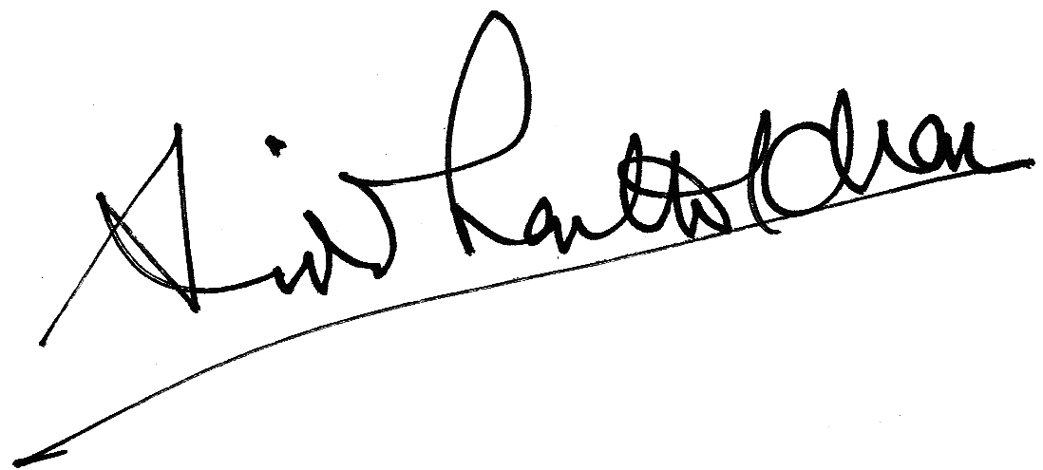
GENERAL SECRETARY

