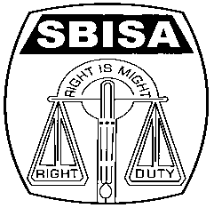 | Website: www.sbisabengalcircle.co.in |  | Telephone No : 2248-6024
 | Telegram : “MILITANT” |  | Tele Fax : 2248-7019 (UNION)
 |  |  | Tele Fax : 2243-6729 (LHO)
STATE BANK OF INDIA STAFF ASSOCIATION
(BENGAL CIRCLE)
(REGISTERED UNDER ACT XVI OF 1926)
(Affiliated with All India State Bank of India Staff Federation)
 | All letters to be addressed  to the General Secretary | “AJIT SEN BHAWAN”  13, Crooked Lane (1st Floor)  Post Box No. 2817  Kolkata – 700 069
CIRCULAR NO. BEN/KOL/31 TO ALL UNITS / MEMBERS DATE: 12.06.2018

FAREWELL TO COM. BHASKAR BHATTACHARYYA,
DY. GENERAL SECRETARY ( HQR) & GENERAL TREASURER, SBISA

Com. Bhattacharyya joined the Bank at the then undivided Calcutta Main Branch (Foreign Exchange Department) on the 17th September 1979 as CCT. In those days, he came close to the leaders of the branch and got associated himself in the Trade Union activities. He was greatly influenced by the leaders like Com. Sankareshwar Datta and Com. Ashok Datta. Later in the year 1984 when Calcutta Main branch was bifurcated into Commercial branch at Park Street, he was transferred to that branch. In the year 1991, he became Delegate to the General Council and continued till the year 2000. In the year 2001, he was transferred back to the Calcutta Main branch and became Assistant Treasurer of the Unit after the Circle Conference in 2001. In 2004, he was transferred under Career Progression to Commercial branch and then to RACPC, Kolkata in 2006. Again in the year 2008 he was transferred back to Calcutta Main branch and after formation of SIB branch in 2010 he was elected Secretary of SIB unit and lastly he was posted at LCPC, Kolkata in 2017.

He is very sound in Computer knowledge, be it Software, Hardware or Networking and therefore, his services were utilised by both the Bank and the Association. In the year 1997, he prepared D-Base programme for the Foreign Exchange department. In 2003, he prepared a Fox-pro programme which helped to stop outsourcing of Govt. Department Job with the active support of the then General Secretary Com. Ashok Dutta. He even created a Website to track loan proposals in the RACPC server for branches to get updated. When he was entrusted with charge in the Staff Co-operative Store, as usual with his tech know-how skill, he migrated all the manual data into the computerised system and recorded a business growth from 28 lacs to 1.00 Crore in just a span of eight years. He even created the Association (Intranet) site for uploading updated information and current developments.

In his chequered Trade Union career he became Vice President of SBISA in May 2011 and then in February 2012 took over as General Treasurer of SBISA after the retirement of Com. Samar Sen. In July 2014, he was co-opted as Vice President of the Circle Union then in Dec’16 he was elected as DGS (MID Corporate) and lastly retiring as DGS (Hqr) in April 2017.

With huge experience behind him, Com. Bhattacharyya has a very candid nature which is reflected in his amiable and amenable behaviour. He has a deep Trade Union conviction and zeal. He always dedicated himself for the members’ cause and enriched the Organization with his invaluable counsel and contribution.

Com. Bhattacharyya is going to retire from the bank’s service as well as from the Organization on 30th June, 2018. His retirement will certainly create a void and his presence will be missed by our Organization. To give him a befitting farewell, we have arranged a Farewell Function on 29th June 2018 at R.N. Mookerjee Hall, The Institution of Engineers (India), 8, Gokhale Road, Kolkata – 700 020 at 5.30 PM where top rung of Federation / SBISA leadership will be present. We wish Com. Bhattacharyya a hale, hearty and active retired life.

We request all our members to attend the Farewell function positively to make it a grand success.

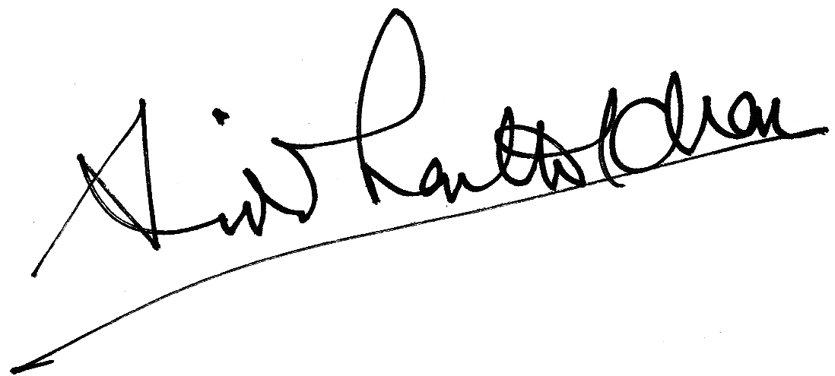
GENERAL SECRETARY

