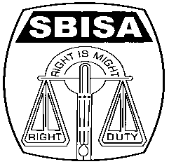 | Website: www.sbisabengalcircle.co.in |  | Telephone No : 2248-6024
 | Telegram : “MILITANT” |  | Tele Fax : 2248-7019 (UNION)
 |  |  | Tele Fax : 2243-6729 (LHO)
STATE BANK OF INDIA STAFF ASSOCIATION
(BENGAL CIRCLE)
(REGISTERED UNDER ACT XVI OF 1926)
(Affiliated with All India State Bank of India Staff Federation)
 | All letters to be addressed  to the General Secretary | “AJIT SEN BHAWAN”  13, Crooked Lane (1st Floor)  Post Box No. 2817  Kolkata – 700 069
CIRCULAR NO. BEN/KOL/9 TO ALL UNITS/MEMBERS DATE: 15.05.2017

1st CIRCLE EXECUTIVE COMMITTEE MEEETING

The first Circle Executive Committee Meeting was held at the Calcutta University Centenary hall campus on the 22nd April 2017 at 6.00 P.M just after the conclusion of the 9th Triennial State Conference of NCBE West Bengal State Federation. The meeting was presided over by Com. President, who at the outset read out the Notice and invited Com. General Secretary to speak on the first agenda of Organizational issues. Com. General Secretary elaborately spoke on the following issues confronting the Association.

- Delay in payment of overtime wages on account of Demonetization.
- Claim of overtime in case of cash replenishment in ATMs.
- Attempt of the Management to force our staff members to become CIFs/ SPs/ ACEs.
- Transfer taking place at LHO against the guidelines of the Corporate Centre.
- The Redeployment, 5 yr transfer to take place only after the Career Progression exercise is complete.
- Renewal of SBISA Medical Benefit fund.
- Cash Transaction after Business Hours.

He also emphasized to maintain organizational discipline and be united at all tiers of the Organization.

On the first agenda, the following speakers participated and expressed their views.Com. General Secretary in his response clarified their queries and also the house adopted some important Resolutions in the meeting.

- Com. Gautam Sengupta, AGS , Siliguri
- Com. Anupam Tarafdar, AGS , Siliguri
- Com. Subir Chatterjee, DGS, Howrah
- Com. Bhaskar Bhattacharyya, DGS, MID-Corporate
- Com. Shyamal Chatterjee, AGS, South 24 Pgs
- Com. Gautam Neogy DGS, Bidhannagar
- Com. Basabjit Roychowdhury, DGS, South 24 Pgs
- Com. Abhoy Deo Sharma AGS ( HQ)
- Com. Anirudhya Bhattacharya, AGS ( Howrah)
- Com. Utpal Mitra, AGS, Mid-Corporate

Then Com. President requested Com. General Secretary to submit on the second agenda, i.e co-option in the posts lying vacant in the Circle Committee. On proposition by Com. General Secretary, the following office-bearers were co-opted and the house approved it unanimously.

- Com. Abhoy Deo Sharma (RBO, Kharagpur) as DGS (Mid- Corporate) in place of Com. Bhaskar Bhattacharya.
- Com. Bhaskar Bhattacharya (SIB, Kolkata) as DGS (HQ) in place of Com. Gautam Banerjee, since retired.
- Com. Debasish Chattopadhyay ( Karidhya branch ) as DGS ( Burdwan) in place of Com. Kazi Abdul Rasid since retired.

On the Miscellaneous agenda, Com General Secretary appraised the House to take immediate initiatives for getting Registration of flat of Late Mohan Lal Majumder. He also apprised the House that a property confiscated by the Bank under SARFESAI Act was purchased by the Circle Association through e- auction near Bangur Hospital, which will be converted into Guest House and that requires some repairing work immediately. The House thunderously approved the proposal. Thereafter, the Meeting ended with vote of thanks to the chair.

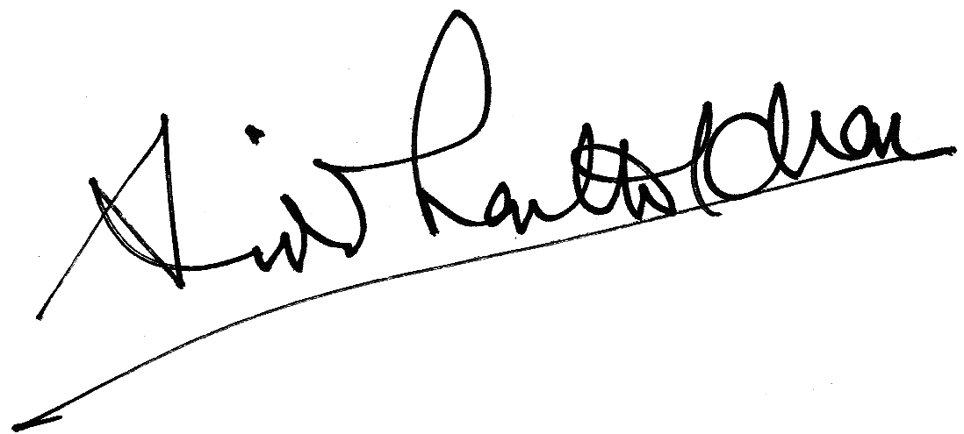
GENERAL SECRETARY

