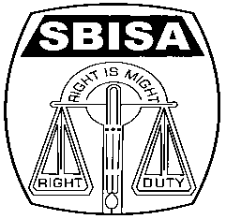 | Website: www.sbisabengalcircle.co.in |  | Telephone No : 2248-6024
 | Telegram : “MILITANT” |  | Tele Fax : 2248-7019 (UNION)
 |  |  | Tele Fax : 2243-6729 (LHO)
STATE BANK OF INDIA STAFF ASSOCIATION
(BENGAL CIRCLE)
(REGISTERED UNDER ACT XVI OF 1926)
(Affiliated with All India State Bank of India Staff Federation)
 | All letters to be addressed  to the General Secretary | “AJIT SEN BHAWAN”  13, Crooked Lane (1st Floor)  Post Box No. 2817  Kolkata – 700 069
CIRCULAR NO. BEN/KOL/11 TO ALL UNITS/MEMBERS DATE: 24.05.2017

TRANSACTION OVER THE COUNTER
AFTER THE BUSINESS HOUR

We reproduce hereunder the full text of our letter No.GS/KOL/45 dated 19.05.2017 addressed to the Circle Development Officer, State Bank of India, Local Head Office, Kolkata on the captioned subject, the contents of which are self explanatory.

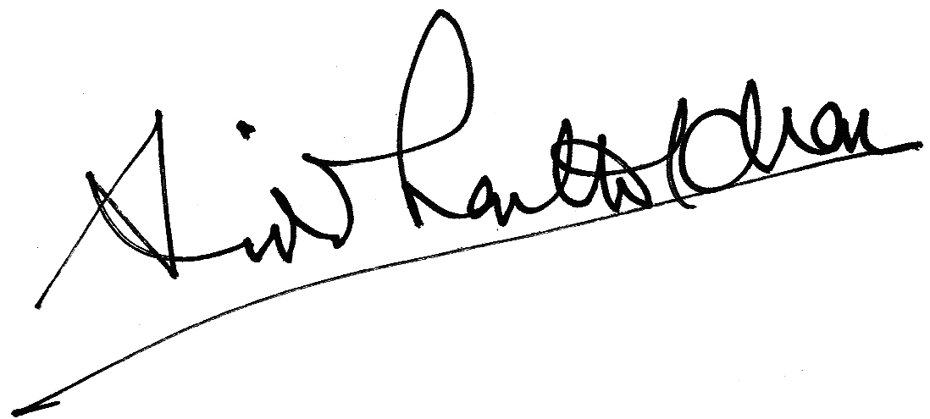

GENERAL SECRETARY
----------------------------------------------------------------------------------------------------------------
Letter No.GS/KOL/45 Date: 19.05.2017

The Circle Development Officer,
State Bank of India,
Local Head Office,
Kolkata.

Respected Madam,

TRANSACTION OVER THE COUNTER
AFTER THE BUSINESS HOUR

We have been informed from different corners that our members attending the frontline counters are forced to serve the demanding customers beyond normal business hours resulting in overstaying beyond working hours without any Administrative orders from the Branch Heads. As a corollary to it, the Special Assistant, Cash-in-charge, are also compelled to stay late beyond 6 P.M and have to leave the office much after the stipulated working hours. We like to draw your kind attention to the fact that in such circumstances, Bank has made provisions to duly authorize such late transactions by a Competent official vide “HR Volume 2 Chapter 3, page 102 clause 3.32(iv) under General Guidelines / Instructions in vogue as well as vide Circular no. CDO/P&HRD-IR/66/2016-17 dated September 9th 2016 under Annexure-A Page 31(h)” quote “On special occasion it might be necessary to attend to cash transaction outside business hours, however due care and caution should be exercised by Management in entertaining such late transactions. Such late transactions should be duly authorized by a Competent official” Unquote. The care and caution as envisaged above by the Bank is due to the fact it may lead to infringement on Section 65 of NI Act which states as “Presentation of cheques for payment must be made during the usual hours of business and if at a bankers’ ‘within Banking hours’ and also infringement on Section 10 of NI Act as the same will not be “ Payment in Due course” if the “payment is made in suspicious circumstances or without reasonable caution or out of the usual course of business, it will not be payment in due course”.

2. We are constrained to inform that despite all such provisions which are indispensable for day to day banking to keep our staff members protected from any unforeseen troubles, the authorization in terms of order for late transaction are not done at the branch level. This leads to dual disadvantage to our members, first the shield is not granted for serving beyond business hours and secondly, the staff members who have to overstay are not requisitioned to do overtime work beyond stated working hours as per the “Guidelines for Overtime work” resulting in non-payment of overtime wages on actual basis thus depriving them of their legitimate claims.

3. You will definitely appreciate that our members working in frontline counters / Grahak Mitras have been performing and taking a lead role in the Bank to promote Alternate channel and Digital Banking thus bringing in a major transformation. The migration of customers to Digital platform and Alternate channel has helped in decongestion of branches but there are branches exceptions to this where customers prefer to do transaction in the branch premises and crowding of customers have not receded or come down despite all sorts of persuasion and the problems of late sitting as mentioned above are reported from such branches.

P.T.O.

Page No. 2

4. In view of the above, we shall be glad if you please arrange to issue Administrative instructions to the Modules to take note of the Bank’s extant guidelines and proper authorizations in terms of office order be made to avoid any conflicting situations to serve customers’ beyond business hours.

Yours faithfully,

Sd/-

GENERAL SECRETARY

NB: AFTER TAKING UP THE ISSUE WITH THE MANAGEMENT FOR CREATING UNDUE PRESSURE ON OUR CLERICAL STAFF MEMBERS ON BECOMING CIFs/ ACEs/ SPs , THE MANAGEMENT HAS ISSUED INSTRUCTIONS TO OBTAIN CONSENT LETTER AT THE TIME OF REGISTRATION TO AVOID COMPLICATIONS OR ANY MISUNDERSTANDINGS AS PER THE IRDAI GUIDELINES VIDE CIRCULAR NO. NBG/PBU/MCS-MCS/6/2016-17 DATED 6TH JUNE 2016.

